**CBECC Program & Ruleset Source Repository** SAC 11/20/17  
(updated for new SourceForge host)

Each major public release and ruleset source code is available in a Subversion (SVN) code repository managed by the CBECC-Res SourceForge.net project site. This document describes how to access this data to facilitate review and development of the CEC residential ruleset and testing of CBECC-Res program releases.

To connect to the CBECC- Res source code repository, follow these steps:

1. 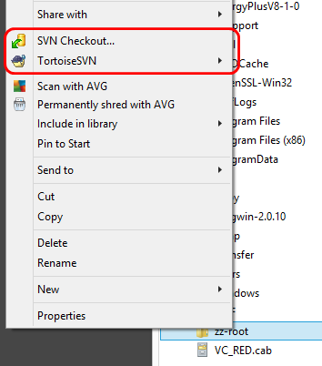Download and install a tool to enable you to interface with the CBECC- Res SourceForge SVN code repository. Recommendation (for Windows) is TortoiseSVN, a free Windows shell extension.  
   Main site & info: <http://tortoisesvn.net/>  
   Downloads: <http://tortoisesvn.net/downloads.html>  
   Once installed you will see new right-mouse menu   
   items in Windows Explorer (circled to the right).  
   The Tortoise SVN options shown here and others in the TortoiseSVN submenu provide access to all the SVN functionality that we use to maintain the repository.
2. 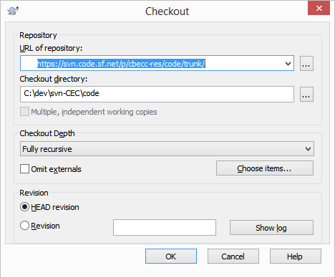 Create a folder on your hard drive that will serve as the root of the program and ruleset source managed by the SVN server. The path to this folder should not be too long, as the code repository will cause the generation of several more directory levels below that.  
   Click on this folder in Windows Explorer and choose “SVN Checkout…” from the ensuing menu (shown above). Fill in the SVN checkout dialog as shown to the right, where the Checkout directory is consistent with the directory you created.   
   There is a fundamental option about what files to maintain a source repository link to – either the entire repository (including various branches and each public release (tags - 4 between ver 3b and ver 4)) with a total size of about 3 GB, OR you can maintain a link only with the active development tree, with a total size of about 550 MB. If only the active development tree (trunk) is desired, then the Checkout dialog should be filled out as shown above, but if the entire respository is desired, then for “URL of repository” enter <https://svn.code.sf.net/p/cbecc-res/code/> (in place of: <https://svn.code.sf.net/p/cbecc-res/code/trunk/> ) (note “trunk/” removed from the end of the path).  
   Upon pressing ‘OK’, all current files in the trunk/repository will be downloaded into your local repository directory.
3. 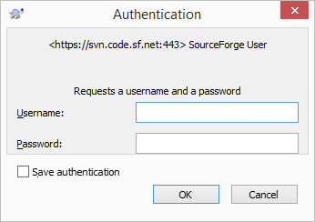The first time you commit changes to the repository you will be asked to provide credentials. Your SourceForge.net username and password should be provided.   
   Make sure to select the “Save authentication” checkbox after specifying your username and password and before pressing OK to avoid having to re-enter this data for future commits.